THE HANDCLASP
FEBRUARY 2023
Growing Disciples for the 21st Century
St. Mark’s Evangelical Lutheran Church
9:00AM and 11:00AM WORSHIP IN SANCTUARY
9:00AM also broadcast on parking lot on 92.1 FM

CONGREGATIONAL MEETING
FEBRUARY 26th
Immediately following our 9am worship service!
Snow makeup date: March 5th
COUNCIL INSTALLATION February 26th
Dear Members and Friends,
It’s hard to believe but Shrove Tuesday (February 21^{st)}, is upon us again and we will be challenged to eat our fill of pancakes and donuts! So why don’t we call this Tuesday before Lent, Pancake day? Believe it or not Shrove Tuesday does have a Christian meaning. The word “Shrove” is a very old word used when referring to the period before Lent, “Shrovetide” (pre-Lenten season). Today we celebrate “Shrove Tuesday” as the day before Lent and no longer celebrate “Shrovetide” . The word “Shrove” is a variation of “shrive” which means to confess and be forgiven. Since “Shrove Tuesday” is the day before Lent begins… that time when we devote ourselves more to spiritual self-evaluation...it makes sense that we would want to begin with an understanding and confession of our shortcomings and a sure knowledge of God’s forgiveness. In a traditional way, it also is the last day to “party” before the more solemn time of Lent. It is after all, the day of the Mardi Gras!

On Ash Wednesday (February, 22nd), we gather to receive Ashes on our forehead in the shape of a cross. We receive a mark of ashes to remember our mortal nature and our call to repentance during the 40 days of Lent. Traditionally, disciples of Christ are challenged to give up something of value (like certain foods or drink) as a way to reflect on the self-sacrificing nature of Christ. Also ,during Lent, we are called to evaluate our spiritual life as Christians. The Church provides mid-week worship to aid in this evaluation.

The week following Ash Wednesday services, Saint Mark’s will continue to provide two worship services on Wednesdays at 1pm and 7pm. During our worship time (on Wednesdays) there will be a video and discussion that will replace the sermon. This year we will be studying the early church and the missionary activities of the Apostles Peter and Paul..
I hope that you can join us for Shrove Tuesday as well as worship on Wednesday’s.
Yours in Christ,
Pastor C. Andrew Carr
SUPER BOWL SUNDAY BAKE SALE
February 12
The confirmation class will be hosting a bake sale on Super Bowl Sunday Feb 12th(after 9am service in social hall after 11am service in the Narthex.) Take some home to enjoy during the game. This fundraiser will benefit the confirmation project to beautify the back parking lot garden.

PLEASE SUPPORT OUR WOCKENFUSS EASTER CANDY FUNDRAISER for St. Mark’s. Brochures are in the narthex. See Margy Ziegler with questions. DEADLINE IS MARCH 5TH.

Join us every month for Breakfast Sandwiches
in the Social Hall between Services
First Sunday of the Month-February 5
Have a sandwich and cup of coffee or juice

SHROVE TUESDAY ACTIVITIES
FEBRUARY 21
7am-9am Drive thru Coffee and donuts

Join us this evening
PANCAKE DINNER
TIME 4:30-7:30

THE CONFIRMATION CLASS NEEDS VOLUNTEERS for the Shrove Tuesday Pancake Supper: cooks, servers set up and clean up .Contact the church office if you can assist.

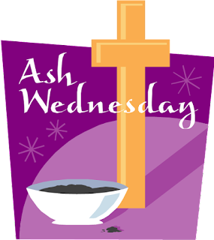
February 22- Ash Wednesday-
12noon -1PM Drive thru Imposition of Ashes in parking lot
Enter using driveway that is south of the church sign
Exit -East Alley behind the church

Evening Worship
7PM worship service with communion and the Imposition of Ashes.

SPOTLIGHT on prayer cHAIN ministry
THE POWER OF PRAYER -
In the Book of James, the 5th chapter, we are given an example of how we as members of the church (the Body of Christ) should pray. 13 “Is anyone among you in trouble? Let them pray. Is anyone happy? Let them sing songs of praise. 14 Is anyone among you sick? Let them call the elders of the church to pray over them and anoint them with oil in the name of the LORD. 15And the prayer offered in faith will make the sick person well; the LORD will raise them up.16 Pray for each other so that you may be healed. The prayer of a righteous person is powerful and effective.”
Here at St. Marks, we are blessed to have a Prayer Chain Ministry. The Prayer Chain is a group of callers who provide a vital service to the church. When a prayer request is called into the office for the prayer chain, you can be assured that it is handled with the care and confidence you need. This important ministry is completed in the comfort of your own home!! The only requirement – your ability to pray and then pass the request along to the next person in the chain.
Currently we have 5 dedicated prayer chain members. We invite you to consider joining our efforts. If you have any questions or feel you would like to join this ministry, please call the church office.
Just a reminder that St. Marks currently has 2 separate opportunities for special prayer intentions should you have a need.

PRAYER CHAIN
The Prayer CHAIN is a group of congregants who communicate by phone or text. They pray in the comfort of their home for a requested concern that has been received by the church office. When the church office receives a request for the prayer chain, the first member of the chain is contacted, and the prayer request is then sent by the members to each member of the chain. The last member of the chain alerts the office that the chain has been completed. All requests are strictly confidential, using only first names and are discussed only within the chain of callers.

PRAYER LIST
The Prayer LIST is a running list of people who have requested additional prayers either by calling in to the office or speaking with the pastor. This list is public knowledge - published in the monthly Handclasp as well as the weekly bulletin. It is the hope that the congregation at large will include this request in their personal prayer time in the coming week. This list is updated as needed and reviewed for editing by the Pastor and the church Office Manager. If you add a name to the weekly prayer LIST, please follow up with the church office so the list can be updated accurately.

If at any time you find that you have a need for additional prayers, please contact the church office and we can help with that need!

THE CHURCH OFFICE will be closed on Monday, February 20,2023 in observance Presidents’ Day.

OFFERING - PLEASE TAKE AN ENVELOPE FROM THE PEW AND MARK WITH YOUR ENVELOPE NUMBER AND NAME. IF YOU DO NOT REMEMBER YOUR NUMBER, PLEASE PRINT YOUR NAME ON THE ENVELOPE.
By using an envelope or using Vanco, we have a church record of your giving and attendance. This information is also important because to be a voting member of the congregation, we need to have a record of you having contributed at worship.

THANK YOU FOR CONTINUING TO SUPPORT THE MINISTRY OF ST. MARK’S through your offering envelopes or by using Vanco!

CHANGE FOR CHANGE: Collection bottles are located at the top of the stairs and at the entrance to the Social Hall. Please take the time to add any of your loose change. Thank you

BIBLE STUDY

Wednesday evenings in Social Hall
45 minutes per session.
Gathering time 6:45 with coffee
7:00- 7:45 Discussion and Bible Study.
Each week is a different lesson. Join us any Wednesday evening that you can.

Based on Book :52 Weeks with Jesus: Fall in Love with the One Who Changed Everything by James Merritt.
Study continues until Wednesday , February 22nd
FROM March 1st through March 29th, there will be worship and study in sanctuary at 7PM
FIRST COMMUNION INSTRUCTION:
Students in kindergarten, first or second grade, who have no received First Communion instruction- please see Pastor Carr

BAPTISM

Noelle Coleman was baptized by Pastor Carr at St. Mark’s on January 7, 2023. Her parents are Holly and Cameron Coleman.. Her Grandparents are Kurt and Amy Sandberg. Her sponsor is Alex Coleman.

Did you know-about our bells?
This Photo by Unknown Author is licensed under CC BY
From the Ziegler family: “The Bells are here because of our daughter,Jess. We were given money and didn't know what to do with it when she passed. My father suggested we buy a two-octave set of bells to honor her memory. So that's what we did. This was before our time here, so when we came to St. Mark's they were not being used at the other church, so we brought them here. The rest is history. I never expected to play them, but I love it. It gives me a connection to her I thought I would never have.” Thank You Margy Ziegler

SUNDAY SCHOOL FOR CHILDREN ages 2 through 5th grade meet on Sunday morning at 9:45 AM. Ages 2 through 4 meet in the nursery with Corinne Sigai. Kindergarten through 2nd grade meet in room 16. Grades 3-5 meet in classroom #20 at the end of the hall. Confirmation class will meet in Youth Room #1

Participants February 2023
9am 11am
February 5 Lois Miller Ginger Jefferson
Usher Greeter: Greg Little Ginger Jefferson
Communion Assistant Stacy Little, Cassie Klein Robin Lewis
Altar Guild: Debbie Lindsay, Stacy Little

February 12 Lector: Warren Miller Robin Lewis
Usher/Greeter: Kurt and Amy Sandberg Sherry Hirth
Communion Assistant: Margy Ziegler, Chris Winemiller Robin Lewis
Altar Guild: Ivy Storey

February 19 : Lector Cassie Klein Sherry Hirth
Usher/ Greeter: Lois and Warren Miller Judy Hafele
Communion Assistant Margy Ziegler Robin Lewis
Altar Guild: Brenda Covington, Margy Ayers

February 26: Lector Dave Hendrix Robin Lewis
Usher/ Greeter: Ken and Margy Ziegler Stuart Hefele
Communion Assistant: Lois Miller, Pam Bamberger Robin Lewis
Altar Guild:Margy Ayers, Brenda Covington

February 22-ASH WEDNESDAY
Lector: Debbie Lindsay
Usher/Greeter: Stephen and Pam Bamberger
Worship Assistant-Margy Ziegler
Communion Assistant:Pam Bamberger, Chris Winemiller
Altar Guild: Pam Bamberger, Margy Ziegler

INCLEMENT WEATHER POLICY
During the winter, if Carroll County School are late or closed, the office will follow. If there is inclement weather on Sunday morning, a decision will be made, a message will be put on the church answering machine and an email sent out.

UPDATED PRAYER LIST AS OF January 26
Karen Smith-home recovering from hip surgery-cousin of Debbie Lang
Jim Mewhirter-home
Brian Charitonuk- in treatment
Rose Bognanni-undergoing cancer treatment-friend of Victoria Garrettson
Ryan Bowles- cancer
Bradley Metz-leukemia-sophomore at Hereford High-friend of Littles
Tina-friend of Lois Miller diagnosed with breast cancer
Wayne Abrell-cancer-friend of Barb Yaruta
Dave Smith- health issues-friend of Buzz Geist
Lenny Steg - in hospital not doing well. uncle to Debbie Lang
Tom Berry - health issues. brother to Debbie Lang
Don Savage, Sr. -leukemia treatment(father and grandfather of
the Savage family)
Mark Spanato-brain cancer-high school friend of Warren Miller
Rose Casazza – lymph node removal-co worker of Genie Klohr
Phillip Stansfield-open heart surgery- friend of Buzz Geist
Marianne Leatherwood-bone infection-friend of Carol Aberts
Jeff Jackson-health issues-brother of Brenda Covington
Barry-cancer treatments, coworker of Ivy Storey
Pastor Kathy Rohrbach- broken femur following a fall
The family of Donald McSwain who entered the Church Triumphant-uncle of Theresa Carr

NEEDED FOR FUNDRAISING
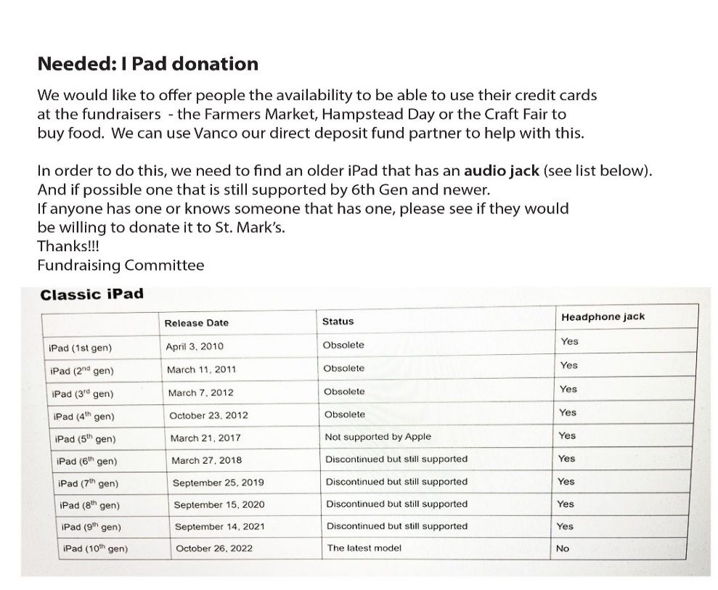

VBS - BLOOM IN CHRIST
A CHANGE TO
St. Mark’s Evangelical Lutheran Church
Easter Flower and Music Fund

This year, in keeping with our efforts to increase our community awareness and outreach, and to spread the good news – a mission of St. Marks…… we will NOT be offering the traditional Easter Lily for purchase. We invite you to donate to our “budding” Vacation Bible School program. We hope, with your help and generous contributions, to increase our capabilities to reach more children. Your contributions will help purchase supplies for not only our St. Mark’s children but others in the community, so they can “BLOOM IN CHRIST”.
To make your contribution, you can send donations to the church office (1373 North Main St. P.O. Box 249 Hampstead, MD 21074) or place it in the offering basket in church clearly marked “VBS - Bloom in Christ”. If you would like to make your donation in honor of or in memory of someone special, please complete the form below. All forms that accompany a donation and are received by April 2, 2023 will be included in the Easter bulletin.

THANK YOU

Provide exact wording-

In Memory of: _______________________________________________

In Honor of: _________________________________________________

To the Glory of God: ____________________________________________

TOTAL AMOUNT ENCLOSED: ___________
(Please make checks payable to St. Mark’s Lutheran Church)

RED CROSS BLOOD DRIVE
BLOOD DRIVE Thursday, February 2, 2023 1:00-6:00PM
Call1 80 Red Cross To Schedule APPOINTMENT

ATTENTION!
Committee Chairs
And organizers of events at St Mark’s

Contact the church office for new forms when hosting a fundraising event at St Mark’s

THE HANDCLASP
FEBRUARY 2023
MARK’S EVANGELICAL LUTHERAN CHURCH
1373 NORTH MAIN STREET
HAMPSTEAD, MD 21074
410-374-6944

E-MAIL ADDRESS FOR ST. MARK’S:
stmarkshampstead@comcast.net

web page address: stmarkshampstead.com

MINISTERS: ALL THE PEOPLE OF ST. MARK’S
Pastor C. Andrew Carr
pastorandycarr.stmarks@comcast.net

Minister of Music: Mr. Jake Ziegler
Office Manager: Mrs. Nancy Klein
Nursery: Mrs. Corinne Sigai

COUNCIL 2023

President: Greg Little
Vice President: Pam Bamberger
Secretary: Warren Miller (acting)
Treasurer: Steve Covington
Financial Secretary: Dave Yaruta

Larry Ridgley, Warren Miller, Ivy Storey, Robin Lewis, Amanda Storey, Ginger Jefferson, Dawn Ridgley

Recording Secretary: Lois Miller

