THE HANDCLASP
NOVEMBER 2022
Growing Disciples for the 21st Century
St. Mark’s Evangelical Lutheran Church
9:00AM and 11:00AM WORSHIP IN SANCTUARY
9AM SERVICE BROADCAST SIMULTANIOUSLY ON PARKING LOT 92.1 FM
SUNDAY SCHOOL 9:45AM

Dear members and friends,
For children and adults, it’s always exciting to count the days to Christmas. Whether you count the time to Christmas using an Advent calendar or Advent wreath, the practice produces the same result. We wait and we anticipate the opportunity to gather on Christmas Eve to sing carols, hear the Christmas story and celebrate the good news that we are never tired of hearing. It is exciting to count the days to Christmas, using the Advent calendar, but the church traditionally uses a weekly calendar. The first Sunday of Advent is always the closest to St. Andrew’s Day, November 30 and there are always four weeks of Advent, however the dates from the first Sunday in Advent until Christmas vary. For instance, this year the first Sunday of Advent is November 27(28 days) and in 2023 the first Sunday of Advent will be December 3 (22 days). Therefore, Christmas Eve is always December 24 and Christmas Day is always December 25. On Sunday November 27, we light will our Advent wreath, signifying the start of the new church year, which is also known as the first Sunday in Advent.

Allow me to review a brief synopsis of the meaning and tradition of Advent and the Advent Wreath.

From the Latin word for “coming”, Advent is a time of preparation and anticipation for the coming of Christ. It represents in the past His incarnation as the baby Jesus, and also the future with His promised second coming as Christ Triumphant. Advent is also a time to focus on His present coming to us in the Word and Sacraments. In the Lutheran church, there have been many traditions observed during Advent that help Christians to prepare for and anticipate His coming at this time. Martin Luther encouraged families to observe Advent as a time for them to teach their children about the coming of Christ.
The Advent wreath tradition dates to the Lutheran Reformation. The wreath is typically made with evergreens in the shape of a circle to represent eternal life. The wreath consists of four blue candles to match Advent’s liturgical color of blue (which is a symbol of Anticipation and hope).

The color and number of candles used on the wreath has changed over the years. Earlier in its evolution, only four candles were used on the Advent wreath. Over time, a fifth candle, the Christ candle, was added and is lit during the time of Christmas, symbolizing that Christ, the light of the world, has come. In years past, three purple candles were used for the first, second, and fourth Sunday’s in Advent with a pink candle used for the third Sunday in Advent. The third Sunday is known as Gaudete Sunday, meaning “rejoice” in Latin and comes from Philippians 4:4. When lighting this third candle, Christians relax to rejoice for the promised Messiah is coming soon.

Counting the days to Christmas coincides with the themes of waiting and anticipation that Advent highlights. My reflection with you reminds us that the Advent wreath’s geometrical shape and use of evergreens symbolizes eternal life given to us through the incarnation, life, death, and resurrection of Jesus. As the Advent season is quickly approaching let us first engage in the discipline of waiting and then celebrate with joy in the coming of our Lord!

Yours in Christ,
Pastor C. Andrew Carr

ALL SAINTS SUNDAY IS NOVEMBER, 6, 2022. If you would like someone included in the prayers that day (entered eternal life Nov 7, 2021-Nov 1,2022) please call or email the church office before Nov.1st^{h} with name, birth date and date of death. Those whose funerals were conducted by Pastor Carr will automatically be included.

TIME CHANGE: Please remember to change your clocks for Nov 6 (back one hour)
THANK YOU for the reception in honor of the 30th anniversary of my ordination. It was a wonderful surprise! The food was delicious and the fellowship with members, family and friends was wonderful. I greatly appreciate the beautiful communion kit! I've already used it twice while sharing communion with shut-ins earlier this week. I am humbled by your generosity and love. Pastor Andy

Thank you to everyone who made the spaghetti dinner a success.

To My St. Mark’s Family:

Thank you so much for the beautiful cards and telephone call that made my birthday so very special. Your love and kindness are true blessings. Louis Georg

ANGEL TREE
Be on the lookout for information regarding our annual Angel Tree community outreach project
BIBLE STUDY

Wednesday evenings in Social Hall. 45 minutes per session. Gathering time 6:45 with coffee
7:00- 7:45 Discussion and Bible Study.
Each week is a different lesson. Join us any Wednesday evening that you can..

Based on Book :52 Weeks with Jesus: Fall in Love with the One Who Changed Everything by James Merritt.
For more details see Pastor Carr
WORSHIP PARTICIPANTS
JOIN THE TEAM! sign up sheets for worship participants (lectors, usher/greeters and communion assistants) are posted on the bulletin board.in the narthex. Please prayerfully consider volunteering

ANNUAL CONGREGATIONAL MEETING to accept 2023 budget and elect council members, December 11, 2022 9:45AM

NOVEMBER WORSHIP PARTICIPANTS:
Lectors: 9AM 11AM
Nov 6 Pam Bamberger Ginger Jefferson
Nov 13 Margy Ziegler Robin Lewis
Nov 20 Chris Winemiller Ivy Storey
Nov 27 Debbie Lindsay Sherry Hirth

Usher /Greeter 9AM 11AM
Nov 6 Stephen & Pam Bamberger Robin Lewis
Nov 13 Lois & Warren Miller Ginger Jefferson
Nov 20 Ken & Margy Ziegler Sherry Hirth
Nov 27 Kurt & Amy Sandberg --

Communion Assistant: 9AM 11AM
Nov 6 Margy Ziegler, Pam Bamberger Robin Lewis
Nov 13 Lois Miller, Cassie Klein Sherry Hirth
Nov 20 Lois Miller, Margy Ziegler Robin Lewis
Nov 27 Lois Miller, Stacy Little Sherry Hirth

Altar Guild
Nov 6 -Margy Ayers
Nov 13 Debbie Lindsay, Stacy Little
Nov 20 Ivy Storey
Nov 27 Brenda Covington,Susan Hines

Join us every month for Breakfast Sandwiches
in the Social Hall between Services
First Sunday of the Month-November 6
Have a sandwich or coffee
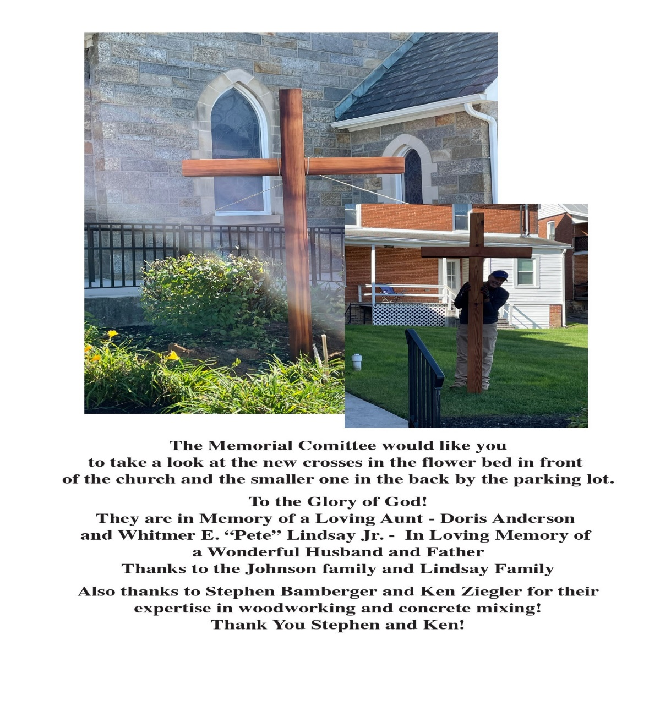

FINANCES
Thank you for continuing the ministry of St. Mark’s through your offering envelopes or by using VANCO

SUNDAY SCHOOL FOR CHILDREN ages 2 through 5th grade meet on Sunday morning at 9:45 AM. Ages 2 through 4 meet in the nursery with Corinne Sigai. Kindergarten through 2nd grade meet in room 16. Grades 3-5 meet in classroom #20 at the end of the hall. Confirmation class will meet in Youth Room #1

CHRISTMAS ORNAMENT
In lieu of poinsettias this year, St. Mark's Lutheran Church is offering you the opportunity to sponsor a Christmas ornament to honor current family members, friends or as a memorial to someone who has passed.
The Lord offers an abundance of Love, Joy and Peace and this stunning cross ornament symbolizes them all! A magnificent dove flies in the center in a spoked wheel, delivering love and peace. Abundance flows from the harvest of grapes, beautifully entwining an ornate cross.
The cross is fashioned from poly resin and finished in a wonderful soft cream shade. The intricate detail of hand painting cannot fail to delight. The box is wrapped with a gold elastic cord. The cost of each ornament will be $5.
Please complete this form and return it with payment to the Church Office or place it in the offering basket on Sunday morning. Checks can be made to St. Mark's. Orders for ornaments will be received through Sunday, December 1 1, 2022.
In Memory of:

In Memory of:

In Honor of:

In Honor of:

Given by:
Total: $

Ornaments will be available for families to keep after the Christmas season and will have the dedication printed on the box.
Ornaments will be available for pick up, after January 8, 2023
A SAMPLE ORNAMENT FOR VIEWING IS AVAILABLE ON THE USHERS CABINET IN THE NARTHEX.

Calling All St Marks Cookie Bakers
The St Marks Evangelism committee will be hosting a Cookie Walk at the St. Marks Craft Fair on December 10.
We cannot do it without your help
Would you consider baking 3-4 dozen cookies for the event
Please contact Lois Miller by November 12th if you are able to assist
Cell 443.841-2840
Email cappy4@rocketmail.com
UPDATED PRAYER LIST AS OF OCTOBER 28
Theresa Carr-in treatment
Barb Yaruta-broken arm
Karen Smith-home recovering from hip surgery-cousin of Debbie Lang
Jim Mewhirter-home
Brian Charitonuk- in treatment
Rose Bognanni-undergoing cancer treatment-friend of Victoria Garrettson
Sally Lewis-following car accident-coworker of Genie Klohr
Ryan Bowles- cancer
Bradley Metz-leukemia-sophomore at Hereford High-friend of Littles
Tina-friend of Lois Miller diagnosed with breast cancer
Jim Cox -cancer-friend of Barb Yaruta
Wayne Abrell-cancer-friend of Barb Yaruta
Joyce Capps-cancer treatment-friend of Kim Zentz
Dave Smith- health issues-friend of Buzz Geist
Christopher Michael Gardner - prayers for comfort as a result of complication with MS – cousin of Theresa Carr.
Lenny Steg - in hospital not doing well. uncle to Debbie Lang
Tom Berry - health issues. brother to Debbie lang
Charles Pearman, spinal surgery- friend of Sharon Dyas

RED CROSS BLOOD DRIVE RESULTS
Goal: 24
Registered: 27
2RBCs: 2 (Power Red Donation)
Deferrals: 5
QNS: 0 (Quantity Non-Sufficient)
Collected: 24 Fiscal Year to Date (July 1, 2022-June 30, 2023) : 47
Next blood drive: Thursday, December 15, 2022

THE HANDCLASP
NOVEMBER 2022
MARK’S EVANGELICAL LUTHERAN CHURCH
1373 NORTH MAIN STREET
HAMPSTEAD, MD 21074
410-374-6944

E-MAIL ADDRESS FOR ST. MARK’S:
stmarkshampstead@comcast.net

web page address: stmarkshampstead.com

MINISTERS: ALL THE PEOPLE OF ST. MARK’S
Pastor C. Andrew Carr
pastorandycarr.stmarks@comcast.net

Minister of Music: Mr. Jake Ziegler
Office Manager: Mrs. Nancy Klein
Nursery: Mrs. Corinne Sigai

COUNCIL 2022

President: Greg Little
Vice President: Kurt Sandberg
Secretary: Warren Miller
Treasurer: Steve Covington
Financial Secretary: Dave Yaruta

Larry Ridgley, Warren Miller, Genie Klohr, Robin Lewis, Amanda Storey, Ginger Jefferson, Dawn Ridgley

Recording Secretary: Lois Miller

